* **Introduction** where you discuss the business problem and who would be interested in this project.

This report compares the lifestyle of the city of Hanoi in Vietnam and Wollongong, Australia. While Hanoi is the capital of Vietnam, a dynamic and bustling city in the heart of booming Southeast Asia, Wollongong, on the other hand is well-known of its slow, relaxing lifestyle with the highest of living qualities. The University of Wollongong is a famous study destination of many bright students in Hanoi, but considering such big difference in lifestyle and culture, it can be challenging for those students to adapt.

* **Data** where you describe the data that will be used to solve the problem and the source of the data.

The data are drawn from Foursquare to statistically examine the life in the two cities. The analysis will provide insights in terms of entertainments, food, nightlife, shopping, cultural diversities to highlight the big gap that many Hanoian students will experience when coming to Wollongong.

Given the extensive size of Hanoi compared to Wollongong, this report will focus on the downtown areas of the two cities to analyzed in detail.

About the datasets:

* Coordinates data: CBD Districts, neighborhoods and corresponding coordinates of each neighborhood for WOL and HAN are drawn from geolocator library (turning venues to coordinates)
* Population data: growth rate and population density rate collected from World Bank database.
* Population: 5-year growth trend and current population density comparison.
* Population comparison between the two cities is a good indicator of the living quality. High population density can be a problematic as it leads to lower living standards, infrastructure quality compromised, air pollution, noise pollution, crimes, urban slums etc.
* Location data of popular venues drawn from Foursquare. **Explore** call to find popular venues surrounding (1000m radius) a location, then group by different categories to further explored.
* Cuisine and entertainment: good food and a bustling nightlife is an important part of many students’ experience, such data on the restaurants, café, coffee shops, bars, the variety of food will be analyzed.
* Culture diversity: Wollongong can be much more culturally diverse than Hanoi given the number of international residents, students in the city. Data on international food and entertainment forms can be drawn to investigate this aspect.

The data only shown some certain aspects of the life in these two cities. Critiques can be raised on the completeness of the data as there are much more local hot spots that are not shown on Foursquare.

1. **Methodology** section which represents the main component of the report where you discuss and describe any exploratory data analysis that you did, any inferential statistical testing that you performed, if any, and what machine learnings were used and why.

This report uses mainly EDA (Exploratory Data Analysis) to deliver insights on the lifestyle of Hanoi and Wollongong, with the purpose to highlight the main differences of the two cities to prepare Hanoian students on the potential cultural shocks upon coming to Wollongong, Australia.

At the macro level, data on the population growth and population density of the two cities are compared to examine any significant gap. As population size is a decisive factor to a place’s lifestyle and culture, as well as living standard.

Location data are drawn from Foursquare to further investigate the popular hot spots of the two cities. Since the size is Hanoi is excessive compared to Wollongong, only location data in the downtown area are taken into consideration. The number, diversity and density of entertainment venues such as cafes, bars, clubs, restaurants, hotels can tell considerably about a city’s culture.

1. **Results** section where you discuss the results.

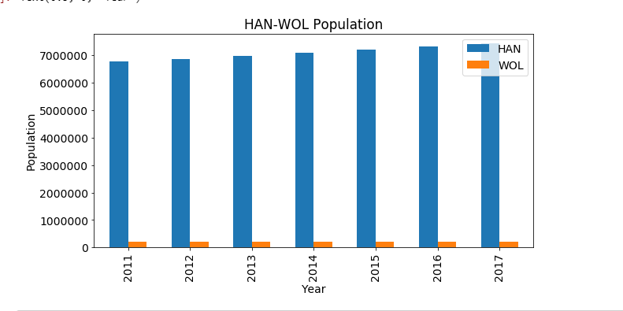

The macro analysis shows that Hanoi population is significantly bigger compared to Wollongong. The latest figures highlights that in 2017, Wollongong population was around 200,000 people compared 7,4 million in population of Hanoi.

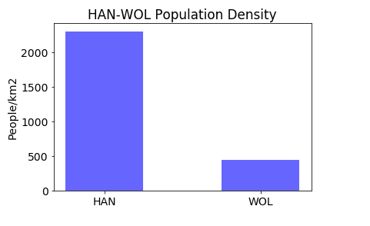

In terms of population density, the same pattern can be seen with the significance of Hanoi’s figure at 2300 people per km2 compared to Wollongong at just around 400 people.

At a micro level, real-time data on the actual streets in the two cities’ downtown areas shows some interesting observations. There are around 140 popular venues in Hanoi, and only half of that in Wollongong, 78 hot spots. In detail, Hanoi downtown offers 21 cafes, 22 restaurants, 7 bars and 16 hotels. These numbers in Wollongong are 14, 19, 6 and 1 respectively. Interestingly, regarding international cuisine, Wollongong offers a wide range of cuisine, from Thai, Japanese, Vietnamese, Australian, Italian, Mexican, Lebanese, Chinese, French…whereas there are mostly Vietnamese restaurants in Hanoi CBD.

1. **Discussion** section where you discuss any observations you noted and any recommendations you can make based on the results.

It is clear that Wollongong has a much higher living standards compared to Hanoi, demonstrated by a considerably lower population density and especially being a city of a highly developed country like Australia. High population density in Hanoi can result in major problems in terms of pollution, urban slums, crimes, health hazards. It can be seen in most developed countries in the world, places with high living standards are often associate with relatively low in population density.

However, in terms of quality of life, fun and entertainment, Hanoi is the place to be. With huge population comes with the booming of all kind of entertaining venues and services. It can be observed from the location data that Hanoi downtown has much more cafes, coffee shops, restaurants than Wollongong. Notably, the number of hotels in Hanoi downtown is 16 compared to just 1 hotel in Wollongong, which is explained by the excessively high number of tourists vising Hanoi. Nevertheless, in terms of cultural diversity, Wollongong performs better as this city offers a much more diverse range of food from all over the world, not just merely traditional Vietnamese food like in Hanoi.

1. **Conclusion** section where you conclude the report.

In conclusion, cultural shocks is inevitable for Hanoian students when coming to Wollongong to study. The data has pointed out some substantial gaps in terms of living pace, culture, entertainment and life standards between the two cities. There is always the trade off when making any decision as a city is worth living or not depends on personal’ perspective and preferences.